# Crime Pattern Detection Using Data Mining

**Why was data driven decision making (3DM) useful in this business case?**

The old-fashioned crime solving is a very long process. Without using data, you have to follow a lot of different steps to solve crimes. So, why not use data for this?   
“Any research that can help in solving crimes faster will pay for itself. About 10% of the criminals commit about 50% of the crimes” (S. Nath, n.d.). It is useful, because if you can detect crimes, even before they actually happen, you can solve them more quickly using data mining.

**How did the organization apply 3DM?**

In figure 1, you see a geo-spatial plot of crime incidents. Each red dot represents an incident. Data is collected at every incident. In table 1 you see a very simplified clustering technique. So, if you collect all these data, you can make some pretty accurate patterns with it. In figure 2 you can take a look at an example of these patterns.

“In a general case it will not be easy for a computer data analyst or detective to identify these patterns by simple querying. Thus clustering technique using data mining comes in handy to deal with enormous amounts of data and dealing with noisy or missing data about the crime incidents” (S. Nath, n.d.).

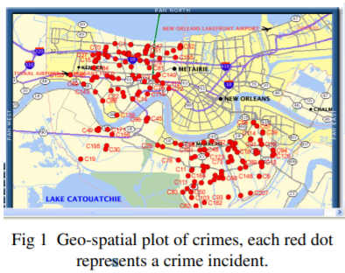Figure 1, 2 and table 1: (S. Nath, n.d.)

**What can the organization do with 3DM that they couldn’t do before?**

Detective can better predict where certain crimes are committed at what location. Also, crime solving could become much less time consuming, because you can skip some steps in solving the crime, because the computer already did this for you.

# Scouting players by using statistics and data analytics in Football

**What was the business problem, and how is it translated into a data mining problem?**

Scouting players for the club you work for is something that has been going on since the beginning of football. Scouts hear that they need to take a look at a certain player, so they are going to watch a couple of games of that player. So when the scout is satisfied with the performance of the player, he is going to recommend him to the manager. This is the old-fashioned way of scouting.

Since a couple of years, a lot of clubs are using data to analyze potential new signings. The best example of this is FC Midtjylland. “They are among the posterboys for analytics in European soccer, a team that scores nearly half of its goals form set pieces and operates a “justice league” that has nothing to do with superheroes” (S. Douglas, 2020). Matthew Benham, a former professional gambler and owner of a company which uses mathematical models to predict the results of sports matches, took over the control at FC Midtjylland.

So, the business problem for most football clubs is: “What is the best way to use data science to scout the best potential players?”

**What is the realized business value?**

There are a lot of benefits of using data science in scouting: “For instance, take a player in the third division in Germany,” Sviatchenko told The Associated Press. “All the statistics they have, you put into the formula and you see this player would actually be able to cope at Bundesliga level. At the moment, he is only playing in the third division but we might take this guy because we know his potential is greater than other clubs will see, and he is maybe not as expensive as a player would be in the Bundesliga” (S. Douglas, 2020).

# Mature data driven business

**What features define a mature data driven business?**

* *You have specialized data roles in place*
* *Your organization is focused on enabling wider data usage*
* You’ve invested in multiple data management projects
* You see data management as a continuous set of processes
* You’ve invested in data quality   
  (Experian, n.d.)

**What are the important features of a data culture?**

A data-driven culture is all about making decisions based on numbers crunched and insights generated using data. This culture encourages organizations to make decisions using reliable data. Important features are that is helps making efficient decisions, it support progress tracking and it increases coordination (V. Vaidya, 2020).

**What are the transformation steps towards a mature data driven business?**

Example: Coca-Cola cleverly leverages the power of image recognition technology and data analytics to target users based on the photos they share socially, giving them insights into the individuals drinking their products, where they are form and how their brand is being mentioned (Unscrambl, 2021).

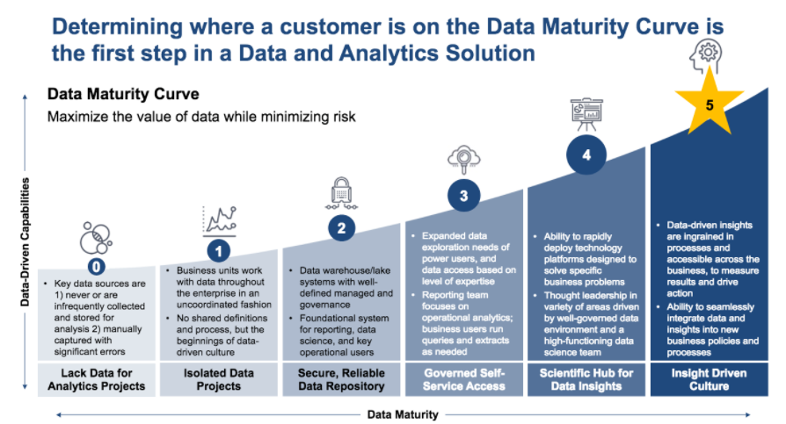“The company combines weather data, satellite images, information on crop yields, pricing factors and acidity and sweetness ratings, to ensure that orange crops are grown in an optimum way, and maintain a consistent taste. The algorithm then finds the best combination of variables in order to match products to local consumer tastes in the 200-plus countries around the world where its products are sold” (B. Marr, 2017).

Grafiek 1 Data maturity curve (World Wide Technology, 2019)

# Literatuurlijst

Douglas, S. (2020, 19 oktober). Data-driven approach taking Midtjylland to heady heights. AP NEWS. https://apnews.com/article/serie-a-champions-league-eredivisie-soccer-europe-2431d25be123e32cea9299b078589963

Experian. (z.d.). 5 signs you’re a mature data driven organization. edq.com. https://www.edq.com/resources/tip-sheets/5-signs-youre-a-mature-data-driven-organization/

Marr, B. (2019, 11 maart). The Amazing Ways Coca Cola Uses Artificial Intelligence And Big Data To Drive Success. Forbes. https://www.forbes.com/sites/bernardmarr/2017/09/18/the-amazing-ways-coca-cola-uses-artificial-intelligence-ai-and-big-data-to-drive-success/?sh=3fd377f778d2

Vaidya, V. (2020). The Importance and Advantages of a Data-Driven Culture. Nisum.Com. https://www.nisum.com/nisum-knows/importance-and-advantages-data-driven-culture

World Wide Technology. (2019, 1 mei). Data maturity curve [Grafiek]. World Wide Technology. https://www.wwt.com/article/data-maturity-curve

# 